**COMPUTER SHOP**

**Diagrams**

**Nguyễn Hoàng Hiệp**

**Mai Minh Quý**

**Phan Hữu Thiện**

**Nguyễn Lương Tuấn Kiệt**

1. **Use-case Diagram:**

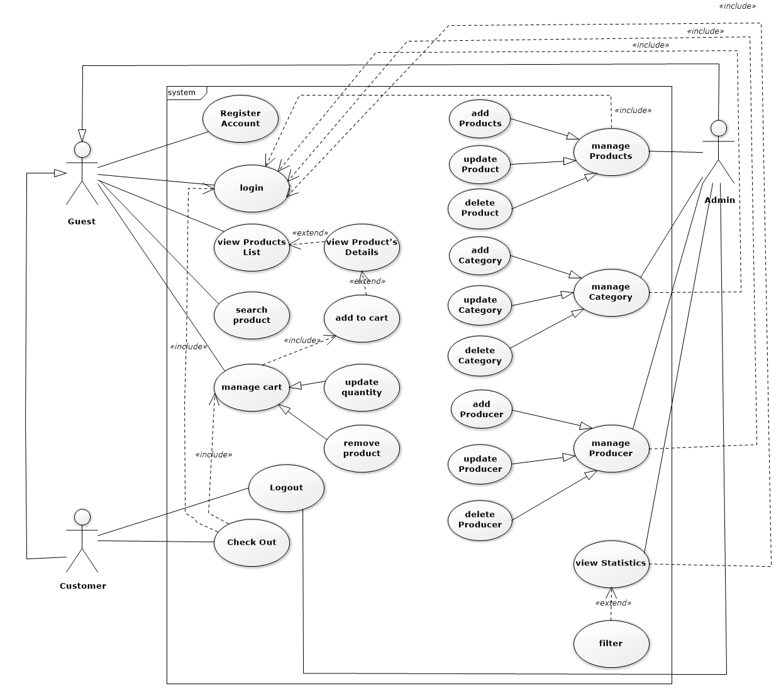

1. **Activity Diagram:**
   1. **Manage Products:**
      1. **Add Product:**

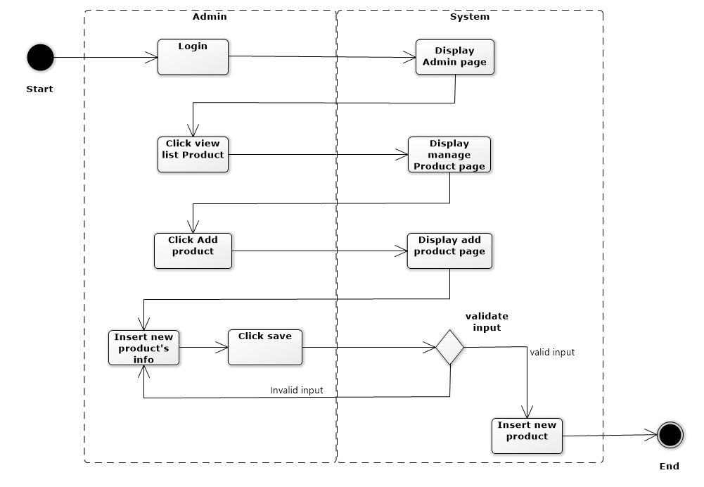

* + 1. **Update Product:**

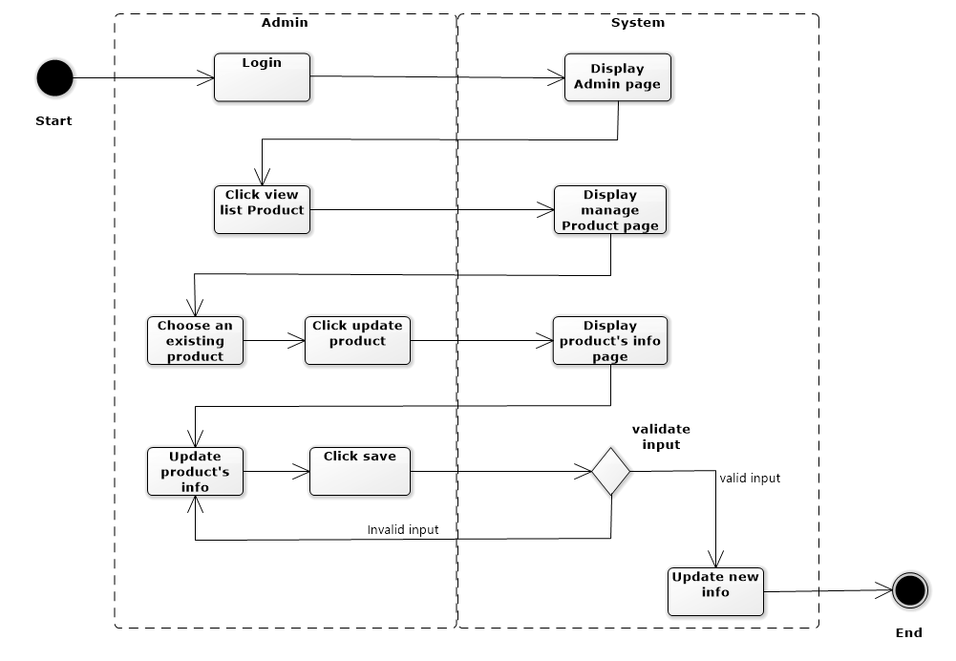

* + 1. **Delete Product:**

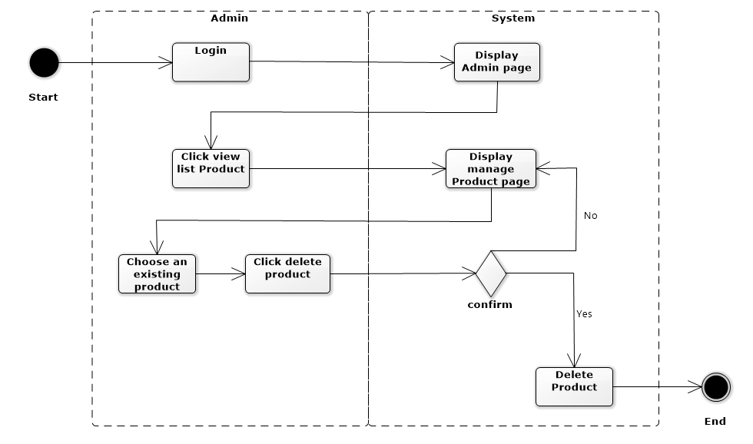

* 1. **Manage Category:**
     1. **Add Category:**

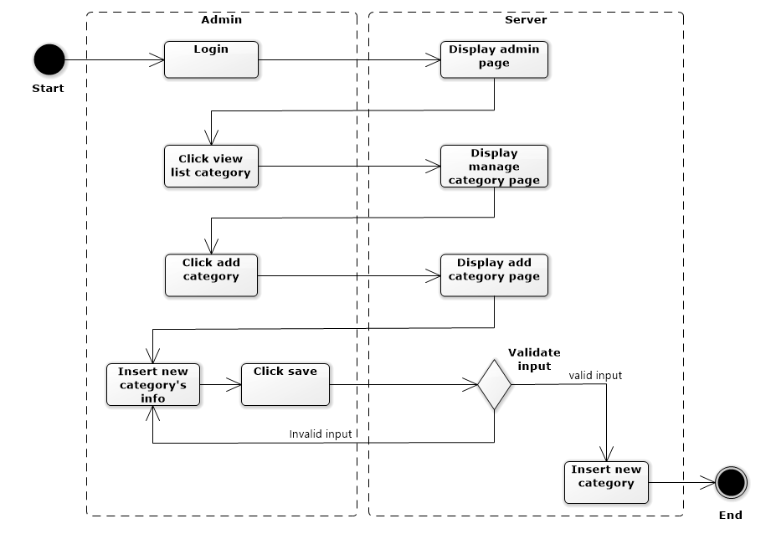

* + 1. **Update Category:**

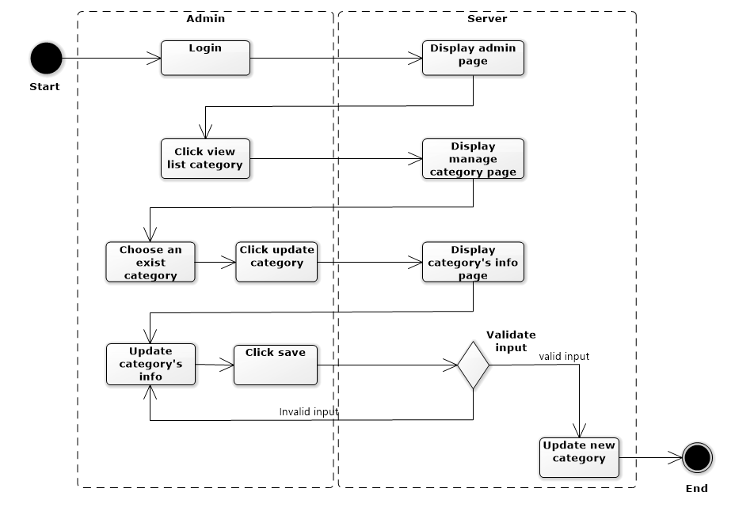

* + 1. **Delete Category:**

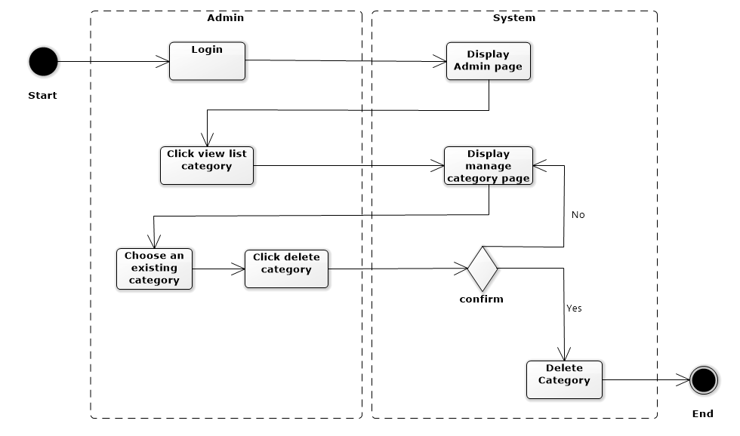

* 1. **Manage Producer:**
     1. **Add Producer:**

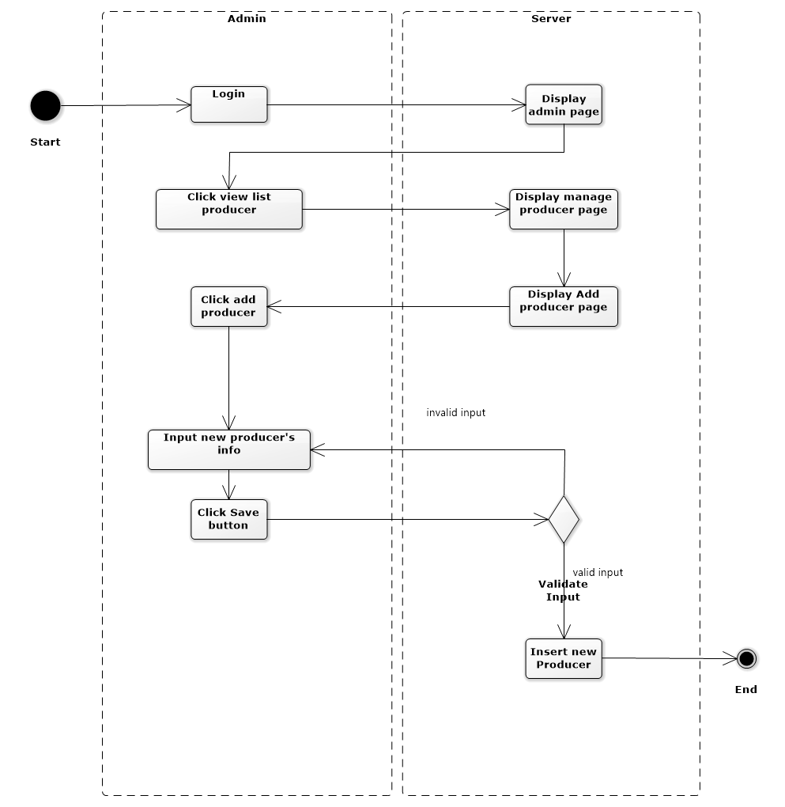

* + 1. **Update Producer:**

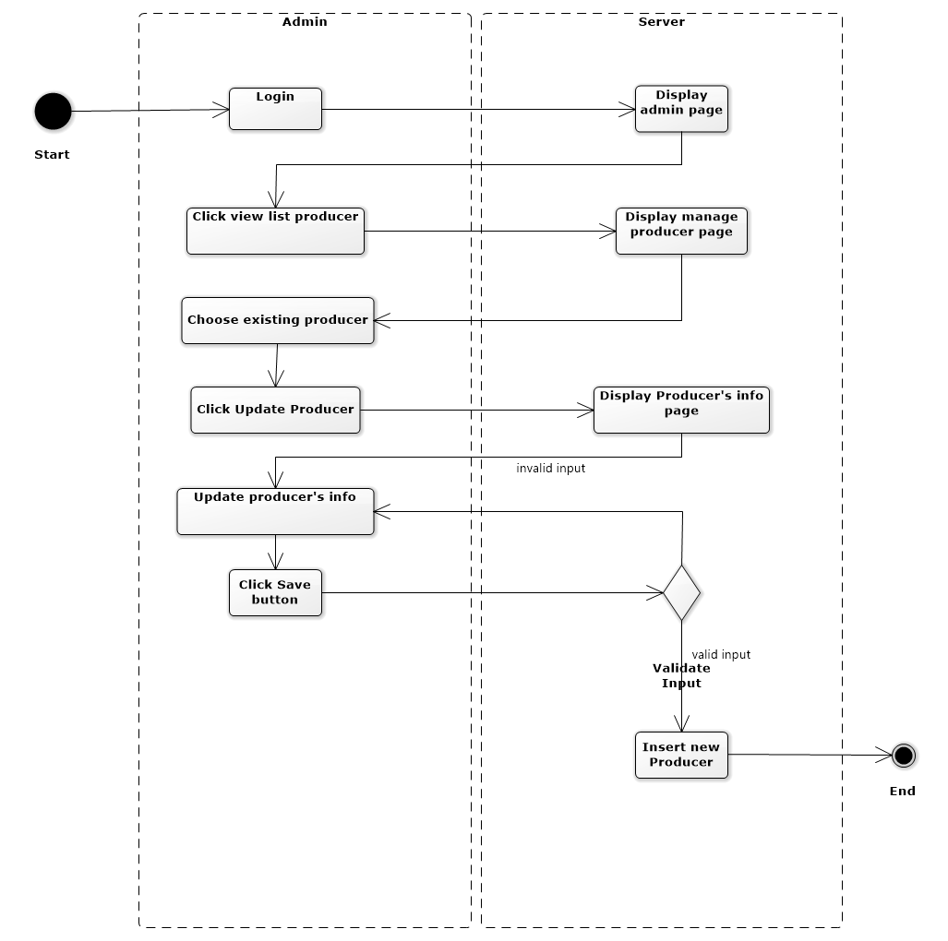

* + 1. **Delete Producer:**

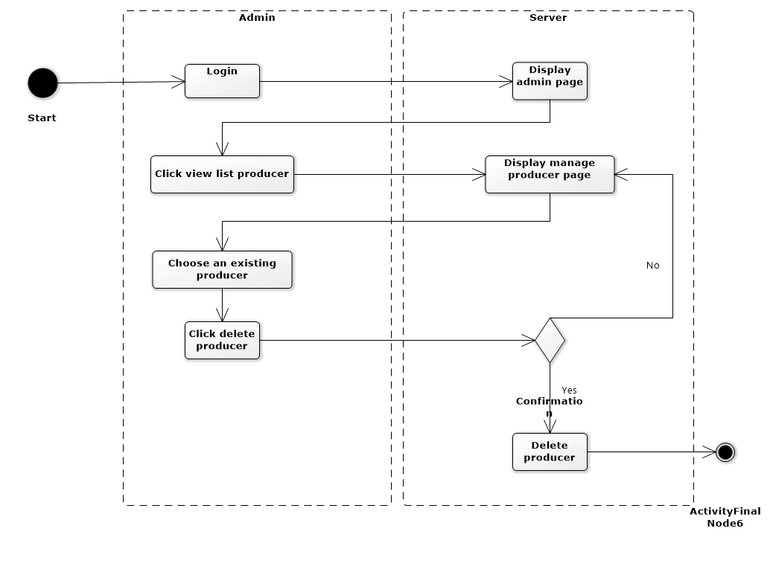

* 1. **Shopping Cart:**
     1. **Add To Cart:**

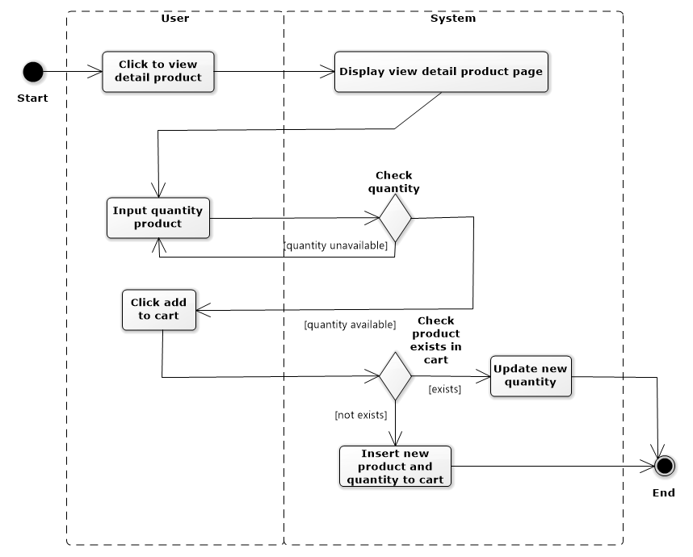

* + 1. **Check out:**

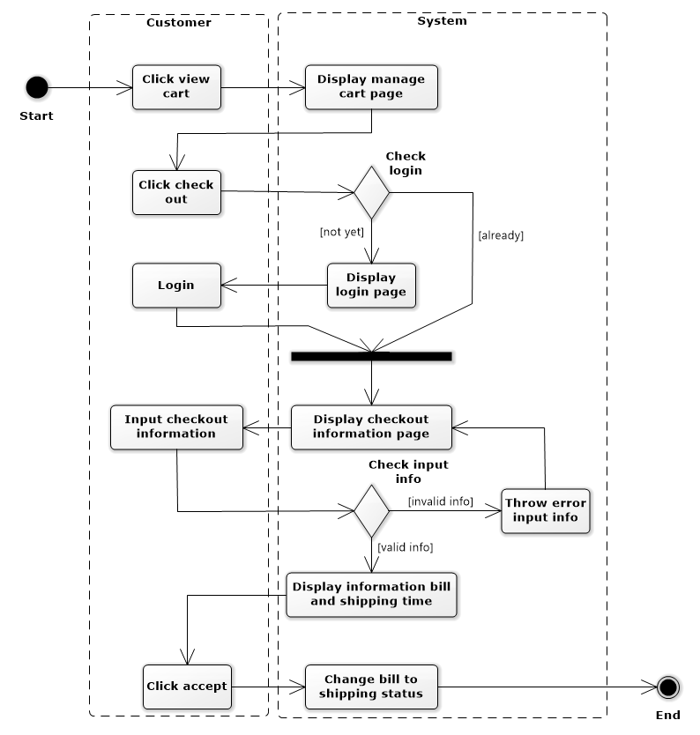

* + 1. **Remove Product:**

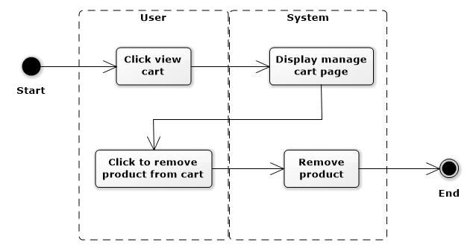

* + 1. **Update Quantity:**

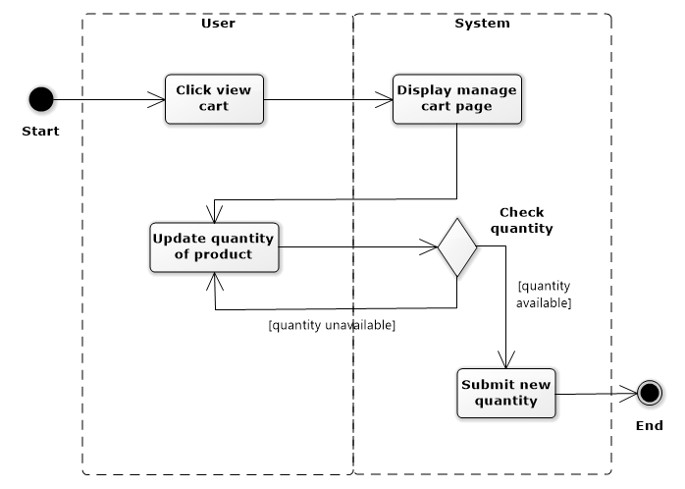

* 1. **View Statistic:**

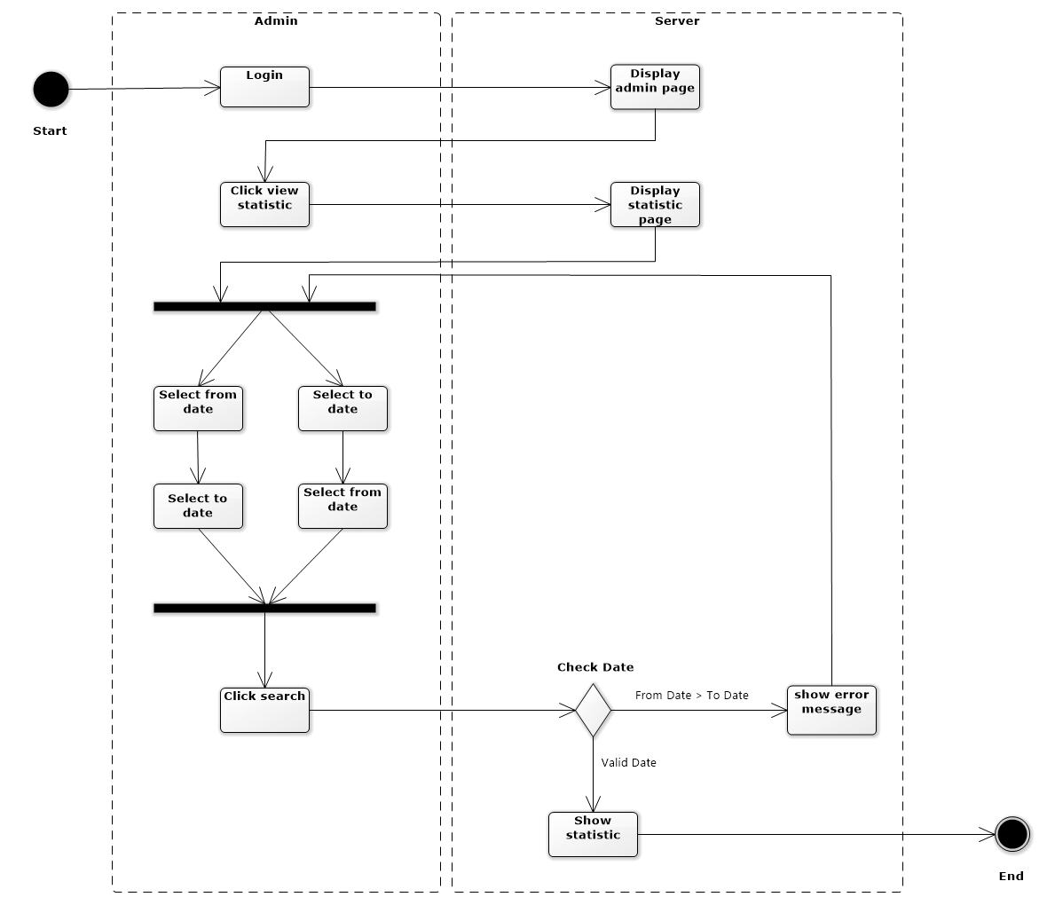

* 1. **Login/Logout/Register:**
     1. **Login:**

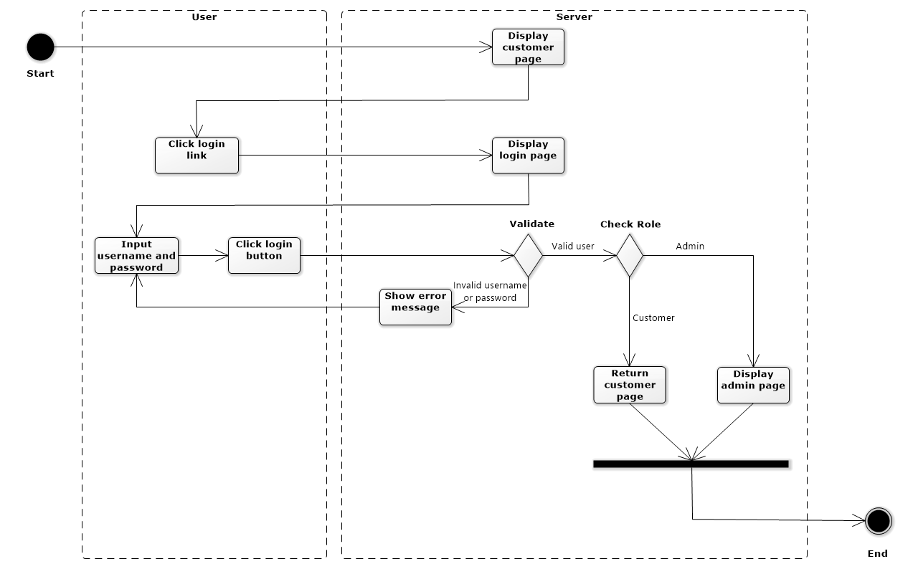

* + 1. **Logout:**
    2. **Register:**

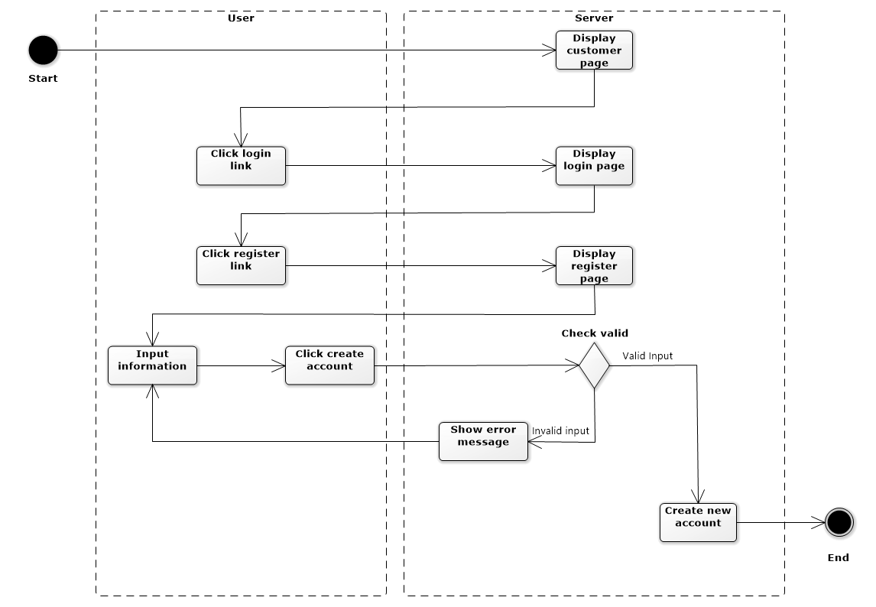

1. **Class Diagram:**

